**STEP 1: Tap on the menu [three white dots] and select smart adaptor**

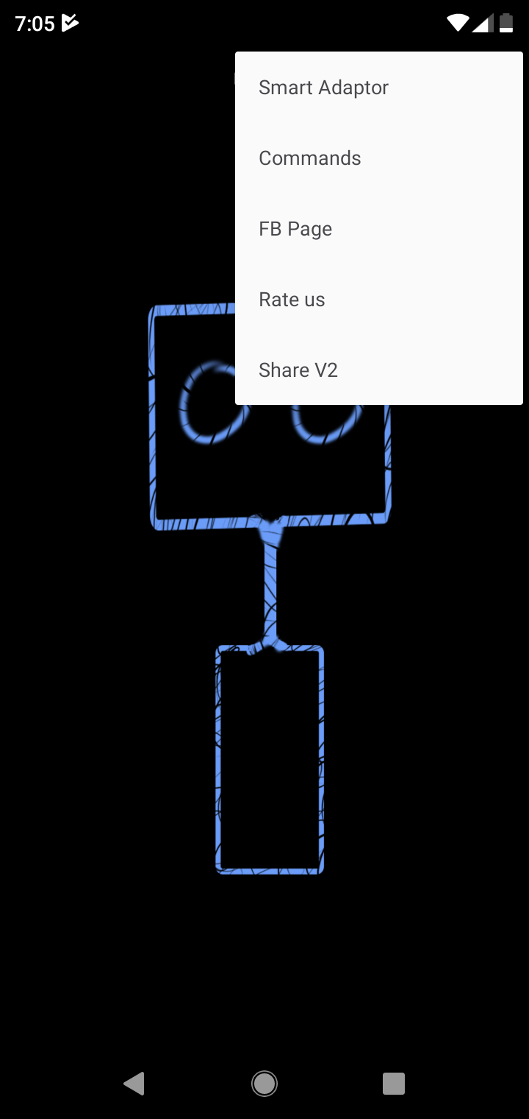

**STEP 2: Then tap the menu and select add**

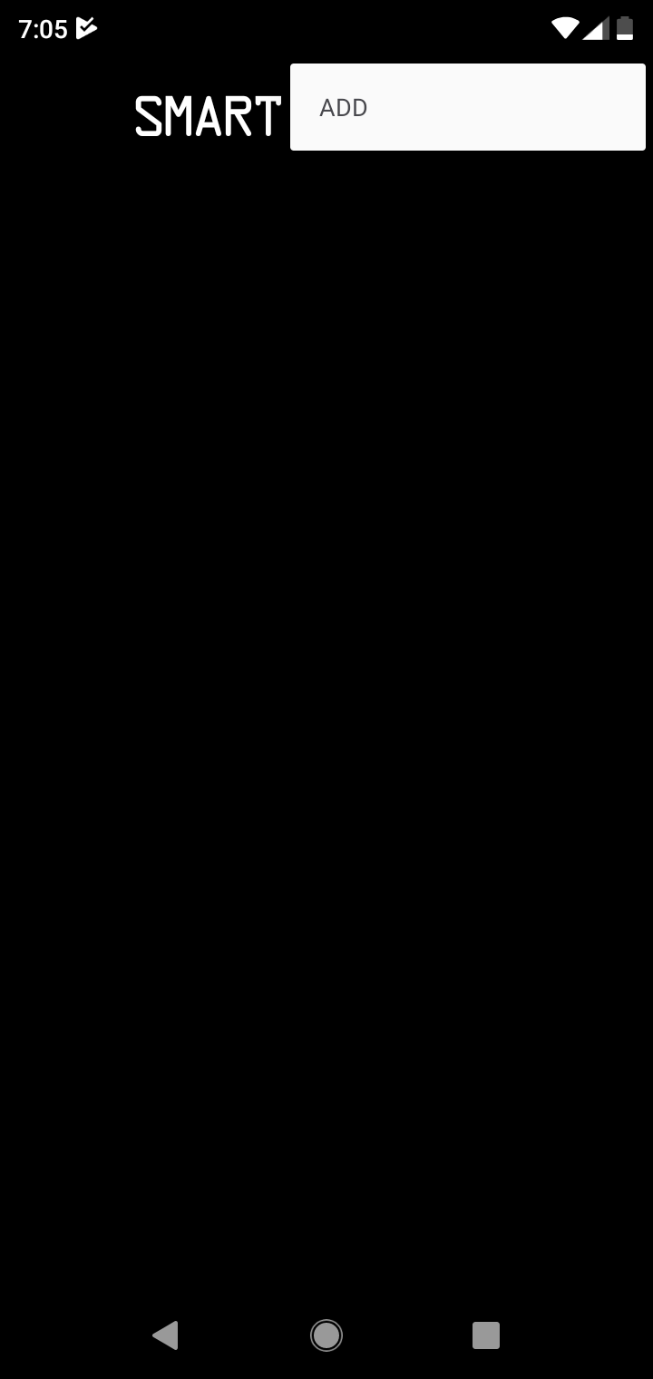

**STEP 3: Then tap next and then fill the WIFI details of your home wifi…. Esp will connect to it…**

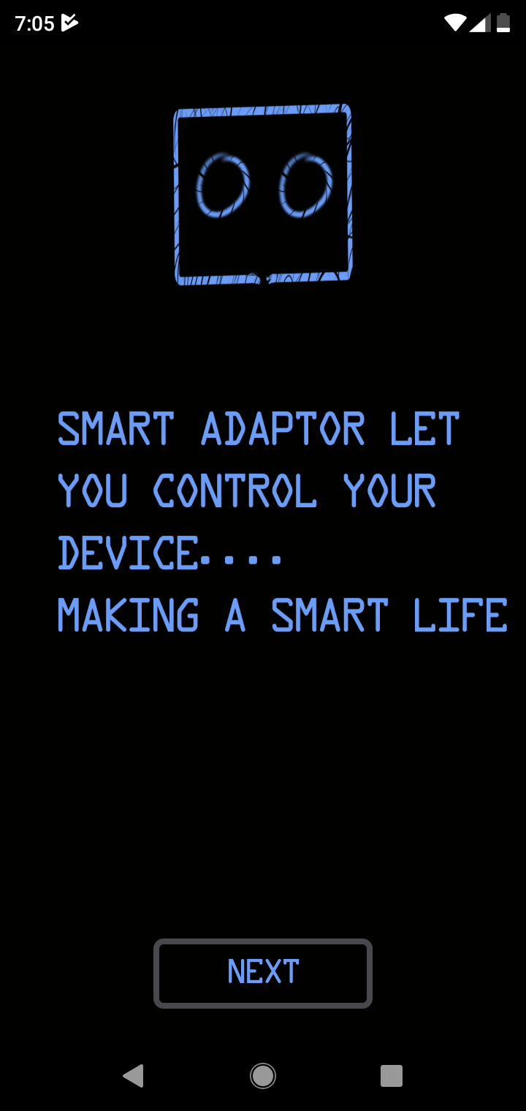

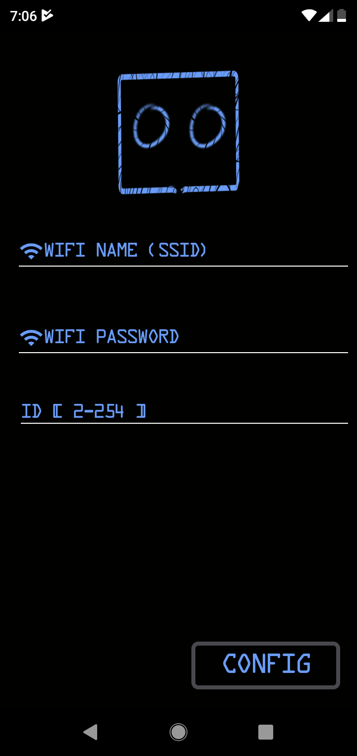

**STEP 4: Click config and then set a name of your smart adaptor and set the ip of the esp[on the wifi]**

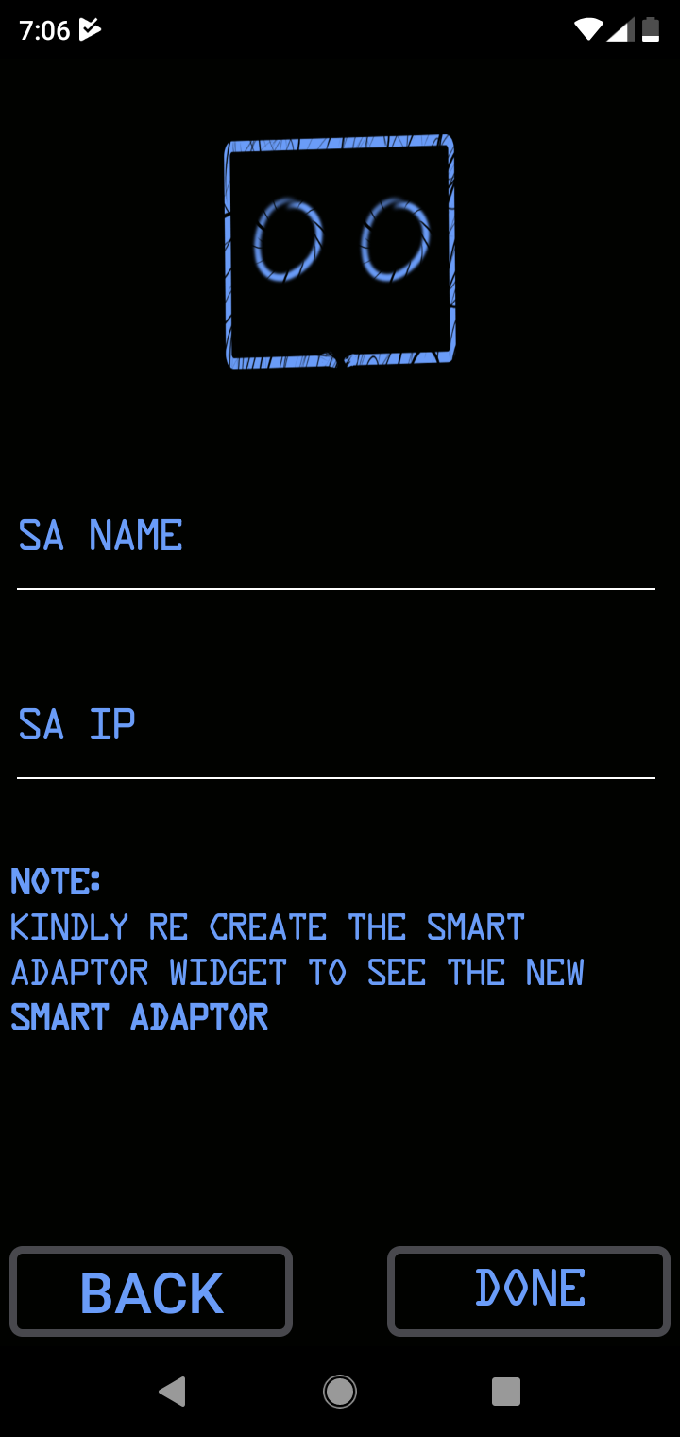

**OUTPUT**

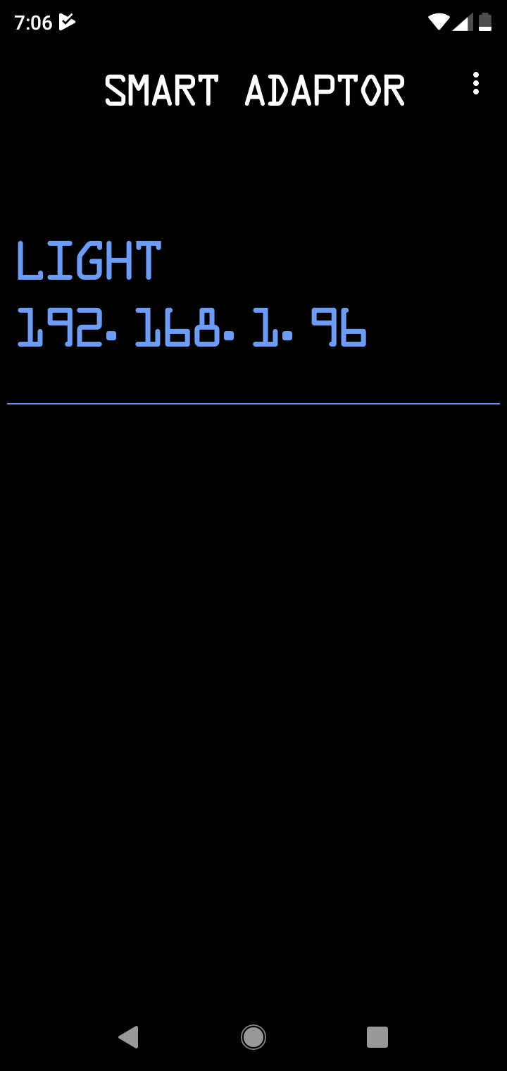

**V2 Widget**

